**Display property**

Since paragraph tags take the whole space in html by making the block of whole html .

To avoid this we can use different tags

Span element is the element which we can update between the paragraph element .

Display property consists of three types :-

* Block
* Inline
* Inline block
* none

1:-Block :- Block property will create the block in this we can adjust the width and the height.

2:-Inline block :-In inline block property we can create the block in inline but in this we can’t adjust the width and the height of the block.

3:- Inline Block :- In Inline block we can create as many blocks in inline and also we can be able to give the height and the width of the block.

None:- This display property is used for disappearing the element .

**CSS Float**

CSS float is a technique which is used for wrapping the text around the element.

With this float property we can arrange the text around the element like :-

Normal text used below the image would be in normal html file :-



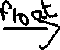

Float property is used in that css where we wanted the text to be floated around

For example, if I wanted my text to be floated around image then I will use that property in image styles.

**Responsive websites**

**How to make websites more responsive , the term responsive means that during this era there are many different different screen sizes so to make our websites adjust to our sizes there are four ways :-**

**1:-Media queries**

**2:-CSS grids**

**3:- CSS flex box**

**4:-Bootstrap**

* Media Query:-In media query we give the maximum width of the websites , if my websites width is less than the max width then it will apply different CSS on it as the user has recommended on it. It starts with the symbol ‘@’ symbol.

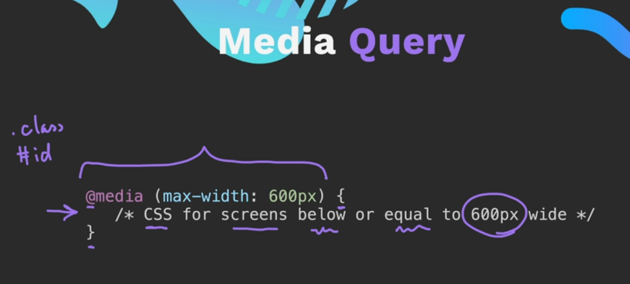

* A screenshot of a cell phone

  Description automatically generatedCSS grids:- This CSS technique is used to create many complex layouts to simple design in just a few lines of code.

Here you can observe that there are many

Design and structures created easily with this

Grid technique.

In this we have to make a container and in that container we can create as many boxes as possible by using this grid technique. It is used for 2-D layouts. Important Keyword

In this we use display: grid

* A blue rectangles with white text

  Description automatically generatedCSS flexbox:-CSS flexbox is another big system just like CSS grids but the difference between them is that in CSS flexbox we are able to build design in 1-D layout. Important keyword in this we use display: flex.

* Bootstrap Framework :- Its an framework since it is external, It is like library which consist of many CSS codes already written in it , we have to just call that keyword and it will have that particular CSS in it .

Media Queries :-Media Queries are basically the queries which we pass to adjust the contents of our website when different resolutions are there like , laptop ,pc , mobiles tv,s etc.

In media queries we can combine the queries :-

